25.68: a) 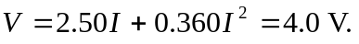 Solving the quadratic equation yields 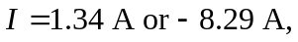 so the appropriate current through the semiconductor is 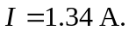
b) If the current 